**MATHEMATICS – FORM FOUR**

**121/2**

**Paper 2**

**121/2 Mathematics (Alt. A) Paper 2**

**Time: 2½ Hours**

**Name**: ………………………………………………………………………………………… **Adm** **No**: ………………… **Class**: ……………………….

**School**:………………………………………………………………………………………… **Date**: …………………….. **Sign**: …………………………

**Instructions to Candidates**

1. Write your name and admission number in the spaces provided at the top of this page.
2. Write your school name, sign and write the date of the examination in the spaces provided above.
3. This paper consists of **Two** sections: **Section I** and **Section II**
4. Answer **ALL** questions in Section I and **any five questions** from Section II
5. Show all the steps in your calculations, giving your answers at each stage in the spaces provided below each question.
6. Marks may be given for correct working even if the answer is wrong.
7. Non-Programmable silent electronic calculators and KNEC Mathematical Tables may be used.
8. This paper consists of **17** printed pages.
9. Candidates should check the question paper to ensure that all the pages are printed as indicated and no questions are missing**.**
10. Candidates should answer the questions in English.

**For Official Use Only**

**Section I**

|  |  |  |  |  |  |  |  |  |  |  |  |  |  |  |  |  |
| --- | --- | --- | --- | --- | --- | --- | --- | --- | --- | --- | --- | --- | --- | --- | --- | --- |
| **1** | **2** | **3** | **4** | **5** | **6** | **7** | **8** | **9** | **10** | **11** | **12** | **13** | **14** | **15** | **16** | **Total** |
|  |  |  |  |  |  |  |  |  |  |  |  |  |  |  |  |  |

**Section II Grand Total**

|  |  |  |  |  |  |  |  |  |
| --- | --- | --- | --- | --- | --- | --- | --- | --- |
| **17** | **18** | **19** | **20** | **21** | **22** | **23** | **24** | **Total** |
|  |  |  |  |  |  |  |  |  |

**SECTION I – 50 Marks**

Answer ***all*** the questions in this section

1. (a) Work out

 (1 mark)

(b) An approximate value is obtained by truncating each value correct to two significant figures. Determine the percentage error arising from this approximation correct to three decimal places. (3 marks)

1. Given that find . Do not use a calculator nor a mathematical table. (3 marks)
2. The trigonometric function has an amplitude of 2.5 and a period of 
3. State the phase angle of the function. (1 mark)
4. Find the values of and . (2 marks)
5. (a) Find the inverse of the matrix  (1 mark)

(b) Hence, find the coordinates of the intersection point of the lines whose equations areand  (3 marks)

1. The figure below represents a cuboid PQRSTUVW such that PQ = 20 cm, PS = 14 cm and   
   ST = 9 cm.

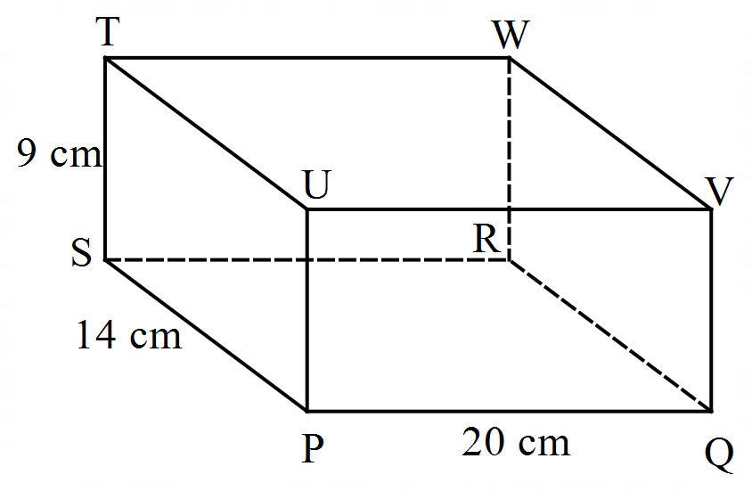

Calculate, correct to 2 decimal places, the obtuse angle between lines UW and SQ. (3 marks)

1. The coordinates of A and B are and respectively. A point T divides AB in the ratio 1:3. Find the position vector of T in terms of unit vectors. (3 marks)
2. A transformation whose matrix is maps a quadrilateral $ABCD$ onto another quadrilateral $A'B'C'D'$ whose area is 540 square units. Find the area of the quadrilateral $ABCD$. (3 marks)
3. There are two examiners A and B marking a Mathematics contest. The table below summarises how each of the examiners marks a bunch of ten papers.

|  |  |  |
| --- | --- | --- |
| Examiner | Number of questions marked accurately | Number of questions marked with deviation |
| A | 6 | 4 |
| B | 7 | 3 |

Calculate the probability that either of the examiners mark with deviation. (2 marks)

1. A firm has a fleet of vans and trucks. Each van can carry 9 crates and 3 cartons while each truck can carry four crates and 10 cartons. The firm has to deliver not more than 36 crates and at least 30 cartons. If  vans and trucks are available for the delivery, write down the inequalities that represent the information above. (3 marks)
2. Make  the subject of the formula:  where is the area between two concentric circles of radii and . (3 marks)
3. The figure below shows a rectangular grazing field PQRS

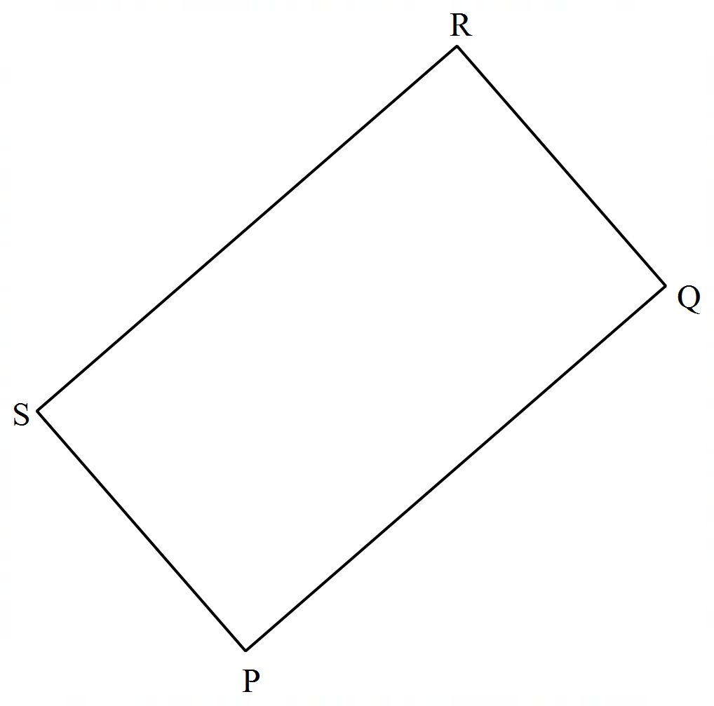

A water trough T is to be constructed within the field. The trough must be nearer to the edge PQ than it is to the edge SR. Angle STR. Shade the region T within which the water trough may be constructed. (3 marks)

1. In the figure below, O is the centre of the circle.

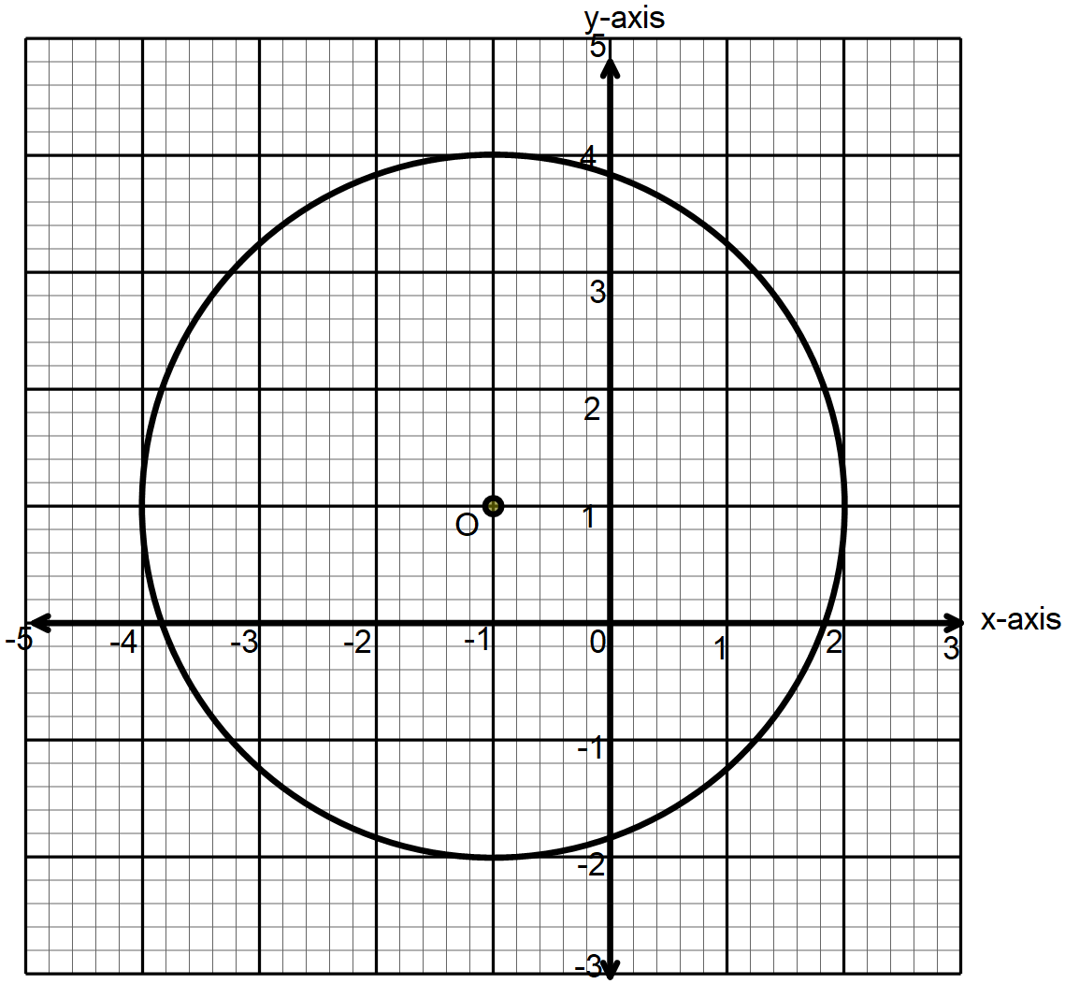

Find the equation of the circle in the form , where ,  and  are constants. (3 marks)

1. (a) Expand in ascending powers of up to the fourth term. Leave the coefficients as fractions in their simplest forms. (1 mark)

(b) Use the expansion in (a) above to estimate the value of  (2 marks)

1. The table below shows the rainfall distribution (in mm) in a weather station for six months of a year

|  |  |  |  |  |  |  |
| --- | --- | --- | --- | --- | --- | --- |
|  | January | February | March | April | June | July |
| Rainfall (mm) | $$105$$ | $$82$$ | $$86$$ | $$126$$ | $$130$$ | $$137$$ |

Calculate the mean absolute deviation for the station (3 marks)

1. In the figure below, O is the centre of the circle. BC = 4.8 cm and ABC

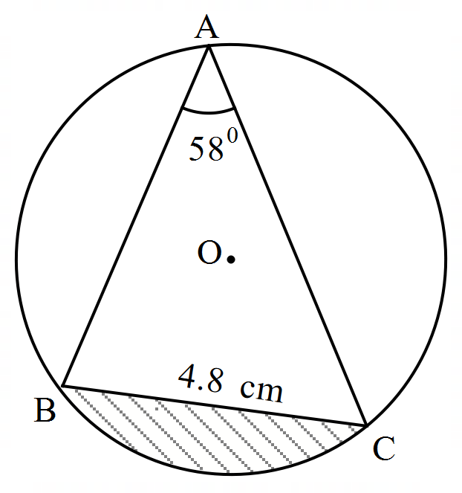

Calculate the area of the shaded area, correct to three decimal places. Use π = 3.142 (4 marks)

**SECTION II – 50 Marks**

Answer any ***five*** questions in this section

1. Income tax rates for a certain year in Kenya were as follows

|  |  |
| --- | --- |
| Taxable income  (Ksh. per month) | Tax Rate  (% in each Ksh.) |
| Up to 13100 | 10 |
| 13101 – 22600 | 15 |
| 22601 – 32100 | 20 |
| 32101 – 41600 | 25 |
| 41601 and over | 30 |

1. In that year, Sarah’s monthly income was as follows: Basic salary Ksh. 72940, house allowance Ksh. 16160 and commuter allowance Ksh. 8000.

Calculate:

1. Sarah’s monthly taxable income. (1 mark)
2. Total income tax charged on Sarah’s monthly income. (4 marks)
3. Sarah’s net monthly tax was Ksh. 21260. Determine the monthly tax relief allowed. (1 mark)
4. A proposal to expand the size of the first income tax band by 20% while retaining the size of the next three tax bands was made. the tax rates would remain the same in each band.

With this proposal, calculate:

1. The tax Sarah would pay in the first band (1 mark)
2. The tax Sarah would pay in the last tax band (3 marks)
3. Lourine uses a drone to deliver cakes to her clients. On a given day, the drone travelled a distance of 30 km on a bearing of 0740 to drop a cake to Nyagot and then it flew to Zoe’s home to drop another cake. Zoe’s house is 25 km from Nyagot’s house on a bearing of S500E. After dropping the cake at Zoe’s house, the drone flew a distance of 40 km on a bearing of 2450 to drop the last cake at Atieno’s store. The drone then proceeded back to Lourine’s house.
4. Using a scale of 1: 500,000, show the relative positions of these places. (4 marks)
5. Using the scale diagram, determine;
6. bearing of Nyagot’s house from Atieno’s store. (1 mark)
7. distance between Zoe’s house and Lourine’s house. (2 marks)
8. Lourine plans to have a distribution store that is equidistant from the homes of Nyagot, Zoe and Atieno’s store.
9. Locate the position of the store. (2 marks)
10. What is the distance of the store from Lourine’s house? (1 mark)
11. Two towns on the earth’s surface are such that Aand B. A pilot can fly from A to B along the parallel of latitude, or along the great circle through the North Pole.
12. Determine the difference in distances of the two routes. Give the answer to the nearest kilometre. Use and km. (5 marks)
13. At 3.20 p.m., the pilot had to fly from B due west at 300 knots for 2 hours to town C

Determine:

1. the longitude of town C to the nearest whole number (3 marks)
2. the local time at C when he landed. Give the answer in 24-hour clock system. (2 marks)
3. (a) The  term of a sequence is given by and the sum of all the terms in the sequence is 
4. Write down the first four terms of the sequence. (1 mark)
5. Determine the last term of the sequence. (4 marks)

(b) The second of a geometric progression is 64 and the fifth term is 8.

Find:

1. the common ratio and the first term. (3 marks)
2. the sum of the first 11 terms of the progression. (2 marks)
3. The table below shows the marks scored by 60 students in a Mathematics exam.

|  |  |  |  |  |  |  |  |
| --- | --- | --- | --- | --- | --- | --- | --- |
| Marks (%) | 31 – 40 | 41 – 50 | 51 – 60 | 61 – 70 | 71 – 80 | 81 – 90 | 91 – 100 |
| Number of Students | 2 | 4 | 9 |  | 13 | 10 | 8 |

1. Find the value of  (1 mark)
2. On the grid provided, draw an ogive to represent the information above. (4 marks)

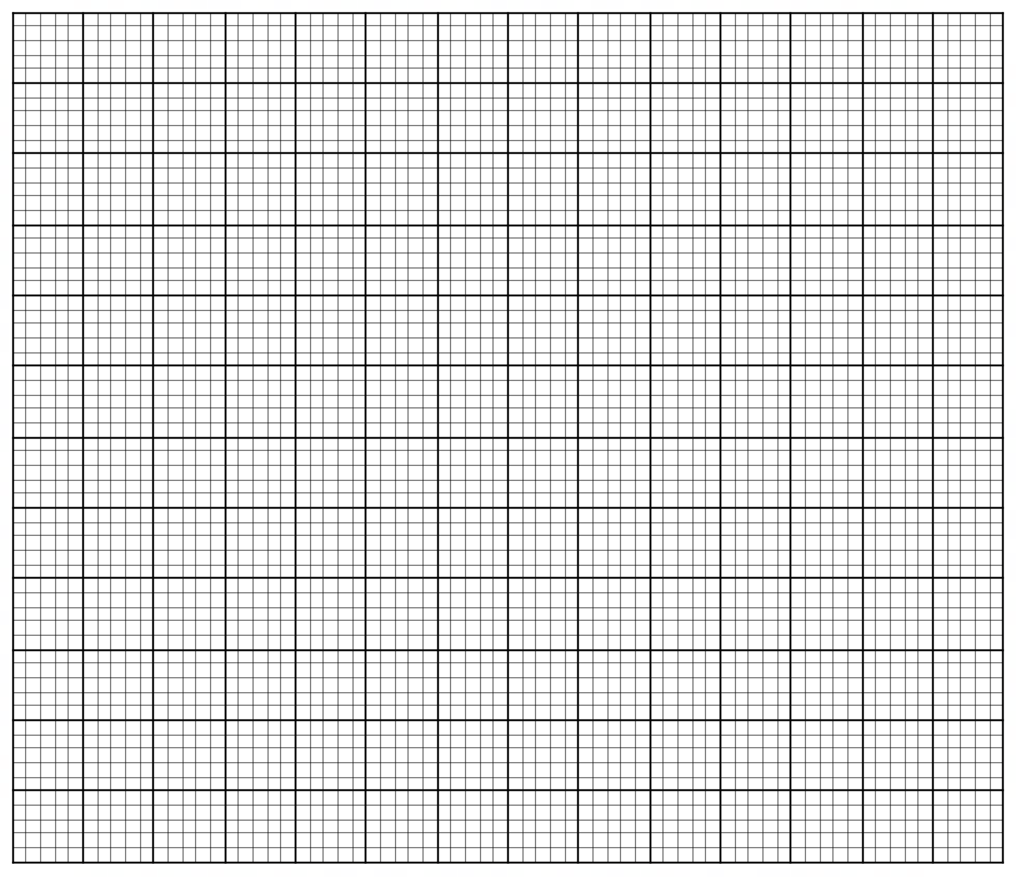

1. Use the graph to
2. estimate the semi-interquartile range (3 marks)
3. determine the percentage of students that passed the exam if the pass mark was set at 45% (3 marks)
4. Water flows through a cylindrical pipe of diameter 4.2 cm at the rate of 50 metres per minute.
5. Calculate the capacity of water delivered by the pipe in one minute. (3 marks)
6. A cylindrical storage tank 3 metres deep is filled by water from this pipe and at the same rate of flow. Water begins flowing into the empty storage tank at 8.30 p.m. and is full 3.10a.m. the next day. Calculate the area of cross-section of the tank in m2. (4 marks)
7. A family consumes the capacity of this tank in one month. The cost of water is Ksh. 50 per one thousand liters plus a fixed basic charge of Ksh. 1650. Calculate the cost of the family’s water bill for one month. (3 marks)
8.  is a trapezium in which A, B, Cand D.
9. (i) On the grid provided, draw the quadrilateral  and its image  under a transformation whose matrix is . (3 marks)

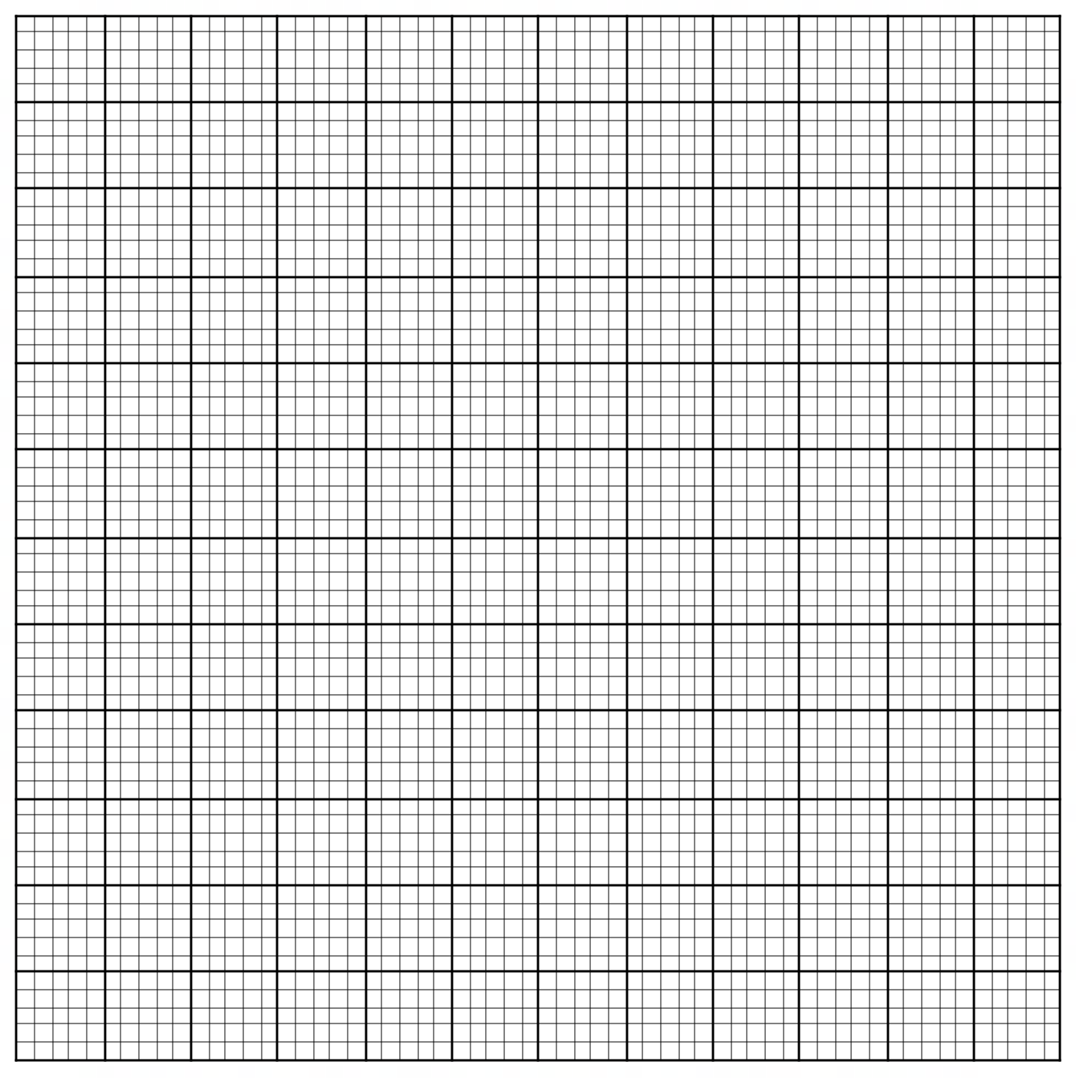

(ii) State the coordinates of  (1 mark)

1. with coordinates , , and  is the image of under a transformation ***T***.
2. On the same grid, draw . (1 mark)
3. Determine the matrix of ***T***. (2 marks)
4. Describe **T** fully. (1 mark)
5. Find a single matrix **M** that maps onto . Hence describe the transformation that maps onto . (3 marks)
6. The acceleration of a particle moving along a straight line is m/s2 and its velocity is  m/s after time  seconds.
7. If the initial velocity of the particle is 3 m/s;
8. express the velocity  in terms of . (3 marks)
9. find the velocity of the particle after 3 seconds. (2 marks)
10. Calculate;
11. the time taken to attain maximum velocity. (2 marks)

1. the displacement of the particle by the time it attains the maximum velocity. (3 marks)